INTEGRATION OF GAMIFICATION AND E-MODULES IN *TAJWEED* LEARNING TO IMPROVE THE QURAN READING SKILLS OF *MADRASAH DINIYAH* STUDENTS

1**Sefilla Ghilda Ikhsani**,2**Djono**,3**Mohammad Muchtarom**

*1,2,3Magister of Educational Technology Program, Faculty of Teacher Training and Education,*

*Universitas Sebelas Maret, Surakarta, Indonesia*

*Author's email:*

[*1sefillaghilda@student.uns.ac.id ;*](mailto:1sefillaghilda@student.uns.ac.id%20;) [*2djono@staff.uns.ac.id ;*](mailto:2djono@staff.uns.ac.id%20;)[*3muhtarom1974@staff.uns.ac.id*](mailto:3muhtarom1974@staff.uns.ac.id)

*Corresponding author:* [*efillaghilda@student.uns.ac.id*](mailto:efillaghilda@student.uns.ac.id)

**Abstract.** *Mastery of Tajweed is essential in Quranic recitation to ensure readings align with proper rules. However, in Madrasah Diniyah, which serves as a non-formal Islamic educational institution, Tajweed learning faces significant challenges. This is evident in students' low proficiency in reciting the Quran with correct Tajweed. This study aims to identify the contributing factors and students’ needs at Madrasah Diniyah Addawam and Madrasah Diniyah Miftahul Huda concerning the use of gamification-based e-modules in Tajweed learning to enhance Quranic reading skills. A quantitative descriptive method was employed, involving 94 students from the two schools. Data collection was conducted through observations and surveys using dichotomous scale questionnaires. The findings indicate that most students encountered difficulties in understanding Tajweed and exhibited low learning motivation. External challenges include the dominance of traditional teaching methods and limited learning media. Despite these obstacles, students demonstrated high interest in gamification-based learning, with 93.3% of students at Madrasah Diniyah Addawam and 75% at Madrasah Diniyah Miftahul Huda expressing support. This suggests that gamification-based e-modules can enhance students' motivation, engagement, and understanding of Tajweed, leading to improved Quranic reading skills. Thus, the development and implementation of gamification-based e-modules offer an effective solution to improve the quality of Tajweed learning at Madrasah Diniyah Addawam and Madrasah Diniyah Miftahul Huda.*

***Keywords:*** *E-Module; Gamification; Madrasah Diniyah; Quran Reading; Tajweed Learning.*

# INTRODUCTION

The Quran is the holy book of Islam, containing the revelations of Allah SWT delivered to Prophet Muhammad SAW through the angel Jibril. It serves as a guide for life, laws, and moral principles for all of humanity (Pransiska & Maulidya, 2024). The Quran is not only a guide for worship, legal matters, and morality but also a source of knowledge that directs humanity towards the path of truth and a balanced life, both in this world and the hereafter (Latifah & Anwar, 2022). Therefore, reading and understanding the Quran properly is an obligation for every Muslim.

One of the institutions that play a significant role in educating Muslims to understand the Quran is the *Madrasah Diniyah* (Madin). *Madrasah Diniyah* is a non-formal Islamic educational institution focused on teaching religious knowledge to students, generally aged between 7 and 18 years (Mamlakhah & Ibad, 2022). This institution holds a central role in shaping the religious character of the younger generation, providing a profound understanding of Islamic teachings, and preserving the tradition of religious scholarship, particularly within Indonesian Muslim communities. One of the main aspects taught in *Madrasah Diniyah* is *Tajweed*, the science of governing the correct pronunciation of letters in the Quran according to precise and accurate rules (Fatihuddin & Abror, 2020). Mastery of *Tajweed* is not merely about pronouncing letters correctly; it is also essential for understanding the deeper meanings of Quranic verses.

*Tajweed* learning in Quranic recitation is a fundamental aspect of Islamic education, particularly in *Madrasah Diniyah* (Madin). Mastering *Tajweed* is crucial in Quranic recitation as it directly relates to the ability to comprehend its content, ensuring that the pronunciation and rules of recitation are clearly understood (Rahma & Zahroh, 2019). However, many students face challenges in learning *Tajweed* due to internal factors, such as a lack of motivation to read the Quran and limited interest in the teaching methods employed, as well as external factors, including family education, inadequate school facilities and infrastructure, prior educational background, and an unsupportive environment (Supriandi, 2021). These factors can present significant challenges for students in improving their Quran recitation skills according to clear *Tajweed* rules.

Based on observations conducted at *Madin Addawam* and *Madin Miftahul Huda*, it was found that the Quran reading skills of students in both *madrasahs* remain relatively low. At *Madin Addawam*, approximately 79% of students face difficulties in reciting the Quran according to proper *Tajweed* rules, while at *Madin Miftahul Huda*, the figure reaches 77%. This low proficiency in reciting the Quran with accurate *Tajweed* highlights an urgent need to improve the quality of *Tajweed* learning so that students can master Quranic recitation correctly. This phenomenon reflects a lack of effective and motivating teaching methods to facilitate a proper understanding of *Tajweed* among students (Ramadhan et al., 2024).

The teaching methods for *Tajweed* in *Madrasah Diniyah* typically involve lectures, memorization, and reading practice, which are limited to a manual approach. According to the findings of Ahmadi, (2020) which indicates that conventional teaching methods tend to be inadequate in facilitating students' willingness to master *Tajweed* in a deeper and more enjoyable manner. Therefore, it is crucial to enhance educational strategies to be more interactive, engaging, and compatible with technological advancements. By leveraging modern technologies such as *Tajweed* learning applications or interactive media, students are expected to more easily master and apply *Tajweed* rules in Quranic recitation efficiently and enjoyably (Najati, 2023).

The use of gamification as a technology-based learning tool offers significant potential to address the aforementioned challenges. Gamification refers to the application of game elements, such as points, levels, and challenges, in non-gaming contexts, in this case, for educational purposes (Srimuliyani, 2023). Integrating gamification into *Tajweed* learning, is expected to create an enjoyable and challenging learning environment that enhances students' sense of achievement. Moreover, gamification can also support increased student motivation to continue learning and practicing, inspiring them to engage in their studies with enthusiasm (Nooviar et al., 2024).

The implementation of e-modules as a digital learning medium can be a highly supportive tool for applying gamification in *Tajweed* learning. E-modules provide flexibility in access and study time, enabling students to independently learn *Tajweed* material, review it as needed, and practice without being constrained by time or place (Anggriani et al., 2024). Considering that *Tajweed* learning in *Madrasah Diniyah* typically takes place briefly outside regular school hours, specifically in the afternoon or after *Maghrib*, the use of interactive and structured e-modules is expected to make it easier for students to understand the rules of Quranic recitation. Additionally, it supports them in revisiting and deepening *Tajweed* material without being limited by the short duration of learning sessions.

The combination of these two elements (gamification and e-modules) has been proven effective in enhancing student engagement and understanding across various learning domains. Previous research conducted by Fatimah et al. (2023) provides evidence that the development of gamification-integrated e-modules for fable texts can support the improvement of students' learning outcomes. Furthermore, previous research by Nisa et al. (2020) also provided evidence that combining these two elements can improve the learning outcomes of set theory for junior high school students. These previous studies have offered substantial evidence that the combination of e-modules and gamification can improve students' learning motivation and engagement. However, there has been limited research specifically integrating these two elements into *Tajweed* learning. Therefore, this study focuses on the implementation of effective teaching materials to assist *Madrasah Diniyah* students in addressing the issue of low proficiency in Quranic learning

This study aims to analyze the needs of students at *Madin Addawam* and *Madin Miftahul Huda* for gamification-based *Tajweed* teaching materials. Additionally, the study seeks to identify the potential of using gamification-based e-modules to address the issue of low Quranic reading proficiency. Thus, the integration of gamification and e-modules is expected to provide an effective and innovative solution to enhance the quality of *Tajweed* learning in *Madrasah Diniyah*, which, in turn, will positively impact students' ability to read the Quran properly and accurately in accordance with prescribed *Tajweed* rules.

# LITERATURE REVIEW

*2.1 Tajweed Learning*

The objective of *Tajweed* learning is to teach students how to recite the Quran properly and accurately according to its rules. According to Munawaroh et al. (2024), mastering *Tajweed* not only enhances the beauty of Quranic recitation but also preserves the authenticity of its meaning. However, challenges in *Tajweed* learning at *madrasahs* are often associated with less interactive teaching methods and students' low motivation to study *Tajweed* (Abadi, 2024). Therefore, innovation in teaching methods, such as the application of digital technology, is highly necessary.

## *Gamification in Learning*

Gamification involves the integration of game elements, such as points, badges, levels, leaderboards, and challenges, into non-game activities to enhance motivation and engagement. Findings from a study by Zebua et al. (2024) state that gamification can create an engaging learning experience while encouraging students to actively achieve their learning goals. Additionally, research by Hayati et al. (2025) shows that gamification can simultaneously improve motivation and learning outcomes, especially when gamification elements are designed to foster interaction and healthy competition. In the context of religious education, particularly Quran memorization, according to Zahro (2024) states that applying gamification in memorizing the Quran can enhance student motivation by encouraging a harmonious collaborative atmosphere. Elements such as interactive quizzes, level-based challenges, and virtual rewards provide a more engaging learning experience for students.

## *E-Module as a Digital Learning Media*

E-modules are digital teaching materials designed for self-directed, flexible, and interactive learning. The use of e-modules is effective in delivering structured and in-depth learning content (Kristiyaningsih & Febrianti, 2024). This effectiveness allows students to access materials anytime and anywhere, enabling them to learn at their own pace (Mutmainnah et al., 2021). In the context of *Tajweed* learning, research by Prasetian, (2023) reveals that the use of e- modules equipped with audio, video, and interactive exercises can improve students' ability to understand *Tajweed* rules. E-modules also allow students to listen to correct recitations and practice them directly, making the learning process more efficient.

## *Integration of Gamification and E-Modules in Tajweed Learning*

The combination of gamification and e-modules offers an innovative approach to overcoming various challenges in *Tajweed* learning. According to Ariswan et al. (2024), this integration provides a more engaging, adaptive, and structured learning experience. Gamification enhances student motivation through game elements such as points, challenges, and leaderboards, while e- modules offer high accessibility and comprehensive materials to support self- directed learning (Supyan et al., 2024; Manggala et al., 2024).

However, obstacles to implementing this integration still exist. A study by Zahara et al. (2021) highlights several difficulties, including:

* + 1. Limited understanding of technology among educators: A significant number of teachers are not familiar with the design of e-modules or gamification elements, necessitating specialized training.
    2. Infrastructure limitations: Not all *madrasahs* have adequate technological facilities, such as computers or internet access, which are prerequisites for using digital e-modules.
    3. Student adaptation to new methods: Students accustomed to traditional teaching methods often require more time to understand how gamification and e-modules work.

Overcoming these challenges requires collaboration among educators, instructional material developers, and education policymakers. With adequate infrastructure support and teacher training, the integration of gamification and e-modules can become an effective and sustainable solution for improving *Tajweed* learning in *Madrasah Diniyah*.

# RESEARCH METHOD

The approach used in this study was quantitative descriptive. Through this approach, the needs of students regarding the integration of gamification and e- modules in *Tajweed* learning were described more clearly and measurably. Additionally, this approach allowed the research to reveal data that reflected actual field conditions, including student participation and the effectiveness of the learning media used, ensuring that the results were more objective and measurable.

The subjects of this research were students from *Madrasah Diniyah Addawam* and *Madrasah Diniyah Miftahul Huda* in Paron, Ngawi. The object of the research was the use of gamification and e-modules as learning media for *Tajweed* to improve Quranic reading skills with correct *Tajweed* rules.

The data collection methods in this study included observation and questionnaire surveys conducted from August to December 2024. Observations were done to identify the teaching methods used in *Tajweed* learning, student participation, and challenges encountered. Meanwhile, the questionnaires contained statements exploring students’ needs for gamification and e-modules, using a 'Yes' or 'No' response format. The processed data from the questionnaires were presented descriptively in the form of percentages and graphs to provide a comprehensive depiction of the student's needs. The data were analyzed descriptively through four stages:

1. Data collection through the distribution of questionnaires to students and direct observation during Tajweed learning.
2. Data reduction: The collected data were filtered to focus on the main findings relevant to the research objectives.
3. Data presentation: The analyzed and simplified data were systematically presented in the form of tables, diagrams, and graphs to make them easier to understand.
4. Conclusion drawing to answer how the potential and needs for the use of gamification and e-modules in *Tajweed* learning can improve Quranic reading skills in Madrasah Diniyah.

# RESULT AND DISCUSSION

*Tajweed* learning is an essential component of Islamic religious education to ensure students' ability to read the Quran according to the established *Tajweed* rules. However, *Tajweed* learning is often perceived as difficult and less engaging for students, highlighting the need for innovative methods to improve Quranic reading skills. One promising approach is the use of gamification-based teaching materials, which integrate educational and game elements to make learning more enjoyable and effective (Hakeu et al., 2023). Gamification, or the use of game elements in learning, is designed to improve students' motivation, cognitive abilities, and concentration through mechanisms such as points, rewards, and challenges (Suparmini et al., 2024). The increased motivation, cognitive engagement, and concentration achieved through gamified *Tajweed* lessons are expected to contribute to improved Quranic reading skills.

The study began with direct observation of 112 students from *Madrasah Diniyah Addawam* and 88 students from *Madrasah Diniyah Miftahul Huda* to assess their Quranic reading abilities. Subsequently, the research sample was selected using purposive sampling, consisting of 50 students from *Madrasah Diniyah Addawam* and 44 students from *Madrasah Diniyah Miftahul Huda*, all aged 10 years and above who had studied *Tajweed*. This sample was used as respondents in a needs analysis for the development of gamification-based e-module teaching materials for *Tajweed* learning to improve accurate Quranic recitation. The analysis was conducted through a dichotomous scale questionnaire (yes and no). Below are the results of the data analysis, starting with the identification of Quranic reading abilities in accordance with *Tajweed* rules.

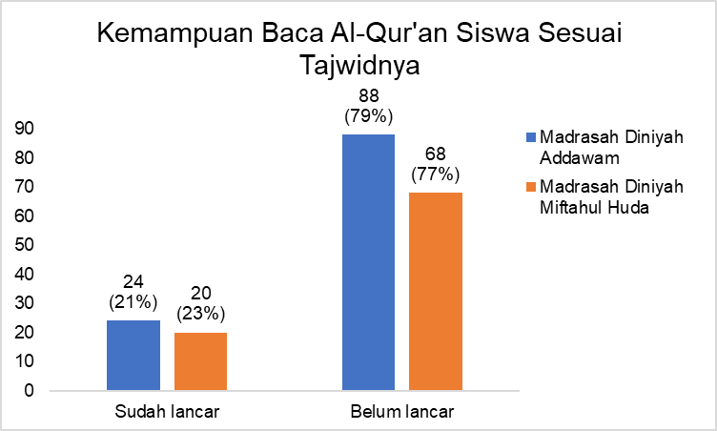

Figure 1. Identification of Quranic Reading Ability

Based on the data in Figure 1, the Quranic reading ability of students according to Tajweed rules at *Madrasah Diniyah Addawam* and *Madrasah Diniyah Miftahul Huda* remains relatively low. At Madin Addawam, 24 students (21%) were proficient in reciting the Quran with proper *Tajweed*, while 88 students (79%) faced difficulties in applying *Tajweed* rules correctly. Meanwhile, at *Madrasah Diniyah Miftahul Huda*, 20 students (23%) were proficient in reciting the Quran with proper *Tajweed*, whereas 68 students (77%) struggled with accurate Tajweed application. This indicates that challenges in reciting the Quran according to proper Tajweed rules need to be further analyzed, both from internal and external aspects.

To further explore the difficulties in reciting the Quran with proper *Tajweed* application at both *Madrasah Diniyah*, a more in-depth analysis of the factors affecting these perceptions is necessary. Initial data indicate that the majority of respondents face difficulties in reciting the Quran according to accurate *Tajweed* rules. However, this perspective needs to be examined further to understand whether these challenges stem from internal aspects, such as students' experience, learning enthusiasm, and the level of difficulty in *Tajweed* learning, or from external aspects, such as the inappropriate use of learning media and teaching methods. Below are the results of the data analysis conducted to determine whether the challenges originate from internal aspects (Figure 2) or external aspects (Figure 3).

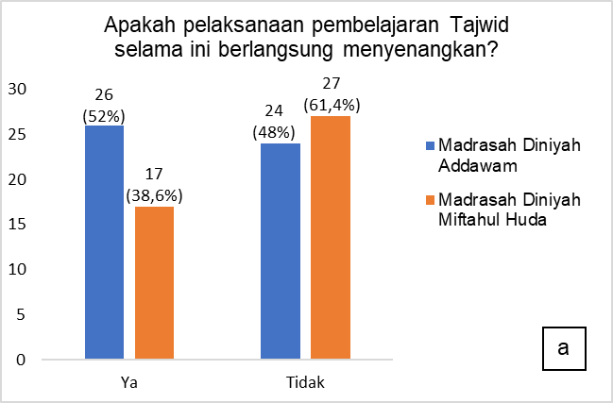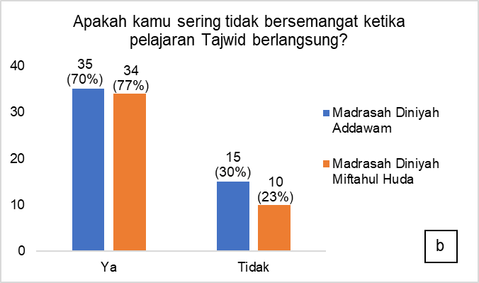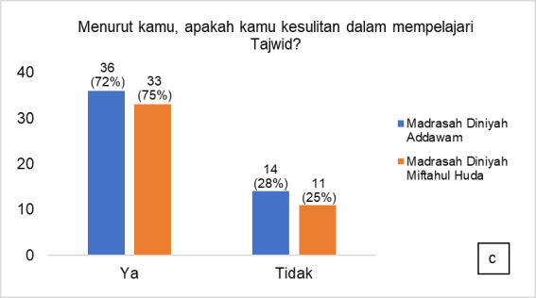

Figure 2. Internal Challenges in *Tajweed* Learning a) Students’ Experience b) Students’ Learning Enthusiasm c) The Level of Difficulty Encountered

Based on data regarding internal challenge factors, three main aspects are highlighted in *Tajweed* learning for proper Quranic recitation: students' experience, learning enthusiasm, and the level of difficulty encountered. In the aspect of students' experience [Figure 2 (a)], at *Madrasah Diniyah Addawam*, only 26 students (52%) found their *Tajweed* learning experience enjoyable, while 24 students (48%) felt otherwise. At *Madrasah Diniyah Miftahul Huda*, 17 students (38.6%) reported having an enjoyable learning experience, whereas 27 students (61.4%) expressed the opposite. The significant difference in students' perceptions of Tajweed learning experiences between the two *madrasahs* indicates that students' interest in the material or teaching methods may be a key factor. If students perceive *Tajweed* learning as boring or ineffective, they are less likely to put in the effort to improve their recitation. This results in their low ability to recite the Quran with proper *Tajweed* due to a lack of motivation and interest in understanding and accurately applying *Tajweed* rules.

In the aspect of students' learning enthusiasm [Figure 2 (b)], at *Madrasah Diniyah Addawam*, 35 students (70%) reported feeling unmotivated to learn *Tajweed*, while only 15 students (30%) remained motivated. A similar condition was observed at *Madrasah Diniyah Miftahul Huda*, where 34 students (77%) felt unmotivated, and only 10 students (23%) displayed enthusiasm for learning. This low learning enthusiasm reflects a lack of intrinsic motivation among students to study and improve their Quranic recitation. Considering that *Tajweed* lessons in *Madrasah Diniyah* are usually brief, and held outside regular school hours in the afternoon or after *Maghrib*, the limited time available could be one of the factors contributing to students' lack of motivation. Consequently, this leads to an insufficient understanding of the material and a lack of serious effort in learning *Tajweed*. Ultimately, this condition negatively impacts their ability to recite the Quran in accordance with correct *Tajweed* rules.

Meanwhile, the level of difficulty in *Tajweed* learning at both *Madrasah Diniyah* represents the greatest challenge [Figure (c)]. At *Madrasah Diniyah Addawam*, 36 students (72%) selected "Yes," while 14 students (28%) selected "No." Similarly, at *Madrasah Diniyah Miftahul Huda*, 33 students (75%) selected "Yes," and 11 students (25%) selected "No." This indicates that when students find it difficult to understand and apply *Tajweed*, they may feel frustrated and lack confidence in reciting the Quran. These difficulties can hinder their ability to apply proper *Tajweed* rules, such as the correct pronunciation of letters or the appropriate length of *madd* (vowel elongation), ultimately contributing to their low proficiency in Quranic recitation according to *Tajweed*. The combination of an unenjoyable learning experience, low enthusiasm, and the high level of difficulty in *Tajweed* learning highlights significant challenges that need to be addressed to improve Quranic reading skills with correct *Tajweed* at both *madrasahs*.

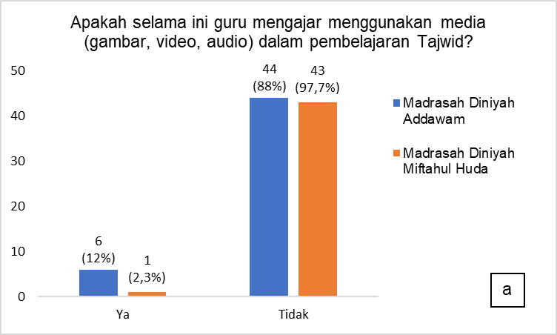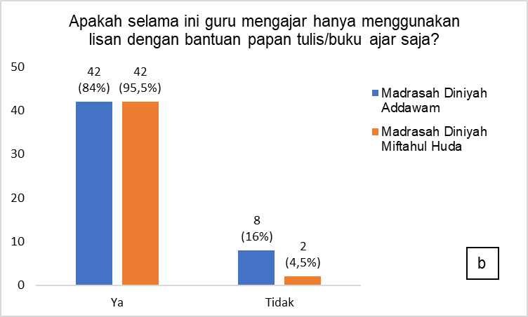

Figure 3. External Challenges in Tajweed Learning a) Use of Learning Media and b) Teaching Methods

Based on data regarding external challenge factors, two main aspects need attention in *Tajweed* learning for proper Quranic recitation: the use of learning media and teaching methods. In the aspect of learning media usage [Figure 3 (a)], the results show that at *Madrasah Diniyah Addawam*, only 6 students (12%) stated that teachers utilized media in learning, while 44 students (88%) informed otherwise. At *Madrasah Diniyah Miftahul Huda*, only 1 student (2.3%) stated that teachers used media in learning, while 43 students (97.7%) reported otherwise. This data indicates that the use of learning tools such as images, videos, or audio is still very limited in both *madrasahs*. The lack of media usage could be one of the factors contributing to students' low proficiency in reciting the Quran properly and accurately according to *Tajweed* rules. This is because more varied learning media can help students better understand and memorize *Tajweed* rules optimally and enjoyably, thereby improving the quality of *Tajweed* learning in both *madrasahs*.

Meanwhile, in the aspect of teaching methods [Figure 3 (b)], the results show that at Madrasah Diniyah Addawam, 42 students (84%) stated that teachers used oral methods with the aid of blackboards or teaching materials, while only 8 students (16%) reported otherwise. At Madrasah Diniyah Miftahul Huda, this method was also predominantly applied, with 42 students (95.5%) responding "Yes" and only 2 students (4.5%) responding "No." This indicates that traditional teaching methods, such as oral explanations and the use of blackboards, remain the dominant approaches used by teachers in both *madrasahs*. Although oral methods with blackboards or teaching materials can effectively deliver content directly, these methods tend to be less interactive and limited in *Tajweed* learning, which requires a deep understanding of sound and accurate pronunciation. The low utilization of more varied learning media, such as audio, video, or interactive applications, may cause students to struggle in practicing proper Quranic recitation due to the lack of visualization and auditory reinforcement, which are crucial for effective *Tajweed* learning.

Overall, the internal and external challenges in reciting the Quran with proper *Tajweed* application at *Madrasah Diniyah Addawam* and *Miftahul Huda* reveal interrelated factors. Internally, an unenjoyable learning experience, low learning enthusiasm, and a high level of difficulty in understanding *Tajweed* reduce students' motivation to improve their Quranic recitation. This directly affects the quality of their recitation. Externally, the limited use of varied learning media and the dominance of traditional teaching methods, such as oral explanations and blackboards, hinder deeper and more engaging *Tajweed* comprehension. Therefore, to optimize students' ability to recite the Quran with proper *Tajweed* application, improvements are needed in both internal and external aspects, such as enhancing the use of learning media and adopting more interactive teaching methods.

Efforts to measure the effectiveness of a new learning model that is more appropriate and relevant to the current needs of students can be made by considering several key factors. These factors include accessibility to smartphones as a learning tool, students’ interest in more modern digital learning, and the potential application of gamification systems to enhance student engagement and motivation. Below are the results of the data analysis conducted to assess the readiness for the new learning method at both *madrasahs*.

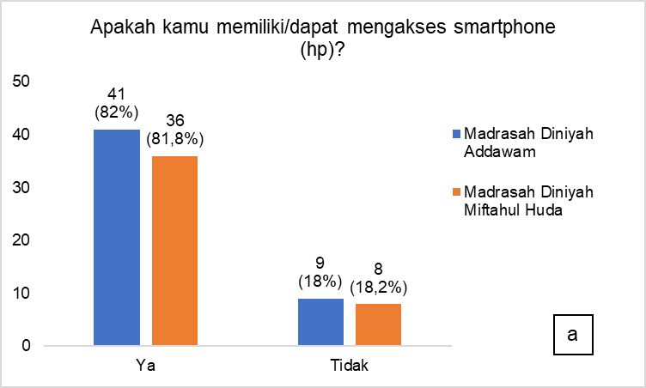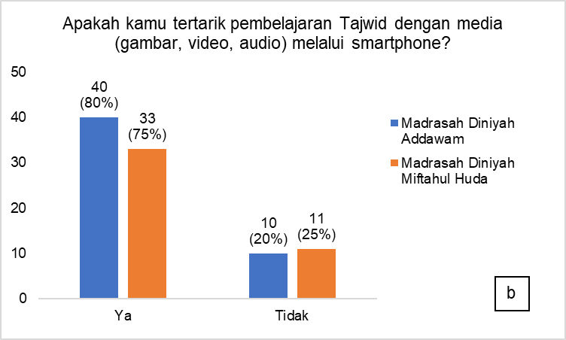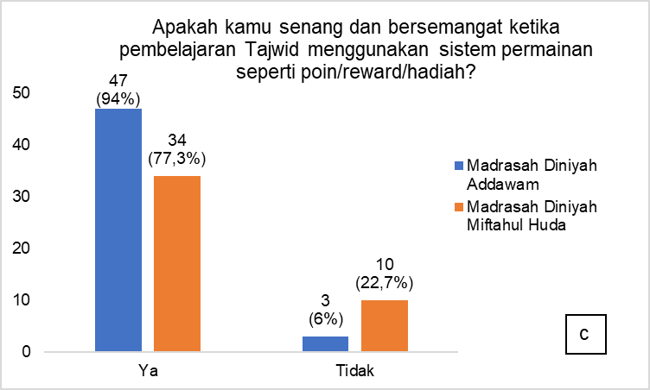

Figure 4. Measuring Readiness for a New Learning Method a) Accessibility to Smartphones, b) Interest in Digital Learning, and c) Interest in Gamification Systems

Based on data regarding the readiness for a new Tajweed learning method, it is evident that the majority of students at both *madrasahs* have access to smartphones [Figure 4 (a)]. At *Madrasah Diniyah Addawam*, 41 students (82%) were able to access smartphones, while 9 students (18%) were not. Similarly, at *Madrasah Diniyah Miftahul Huda*, 36 students (81.8%) had access to smartphones, whereas only 8 students (18.2%) did not. This indicates that smartphone-based technology holds significant potential for integration into learning.

Students' interest in digital learning is also relatively high, as shown in [Figure 4 (b)]. At *Madrasah Diniyah Addawam*, 40 students (80%) expressed interest in teachers using learning media via smartphones, while 10 students (20%) were not interested. At *Madrasah Diniyah Miftahul Huda*, 33 students (75%) expressed interest, whereas 11 students (25%) did not. This data indicates that digital learning through smartphones can be a relevant and appealing method for the majority of students. The use of interactive and engaging digital media could serve as an effective solution to improve students' ability to recite the Quran properly and accurately in accordance with Tajweed rules.

Furthermore, the aspect of interest in gamification systems [Figure 4 (c)] received the most positive responses. At *Madrasah Diniyah Addawam*, 47 students (94%) expressed interest in this system, while only 3 students (6%) were not interested. At *Madrasah Diniyah Miftahul Huda*, 34 students (77.3%) showed interest, and 10 students (22.7%) did not. This indicates that gamification-based *Tajweed* learning has significant potential to enhance student engagement and motivation. This potential is particularly crucial given the current low proficiency of some students in reciting the Quran properly and accurately according to *Tajweed* rules. The implementation of gamification could serve as an effective solution to address these challenges, making learning more engaging and interactive. With game elements applied in *Tajweed* learning, students can more easily understand and memorize *Tajweed* rules while applying them in Quranic recitation. This approach is expected to improve students' skills in reciting the Quran accurately, while also making the learning process more enjoyable and motivating them to keep practicing.

Overall, the data on the readiness for a new learning method indicates that students at both *madrasahs* are prepared to adopt technology and gamification-based learning methods. The majority of students have good access to smartphones and show a high level of interest in gamification-based digital learning. Below are the results of the analysis regarding the acceptance of the proposed solution, namely gamification-based e-modules.

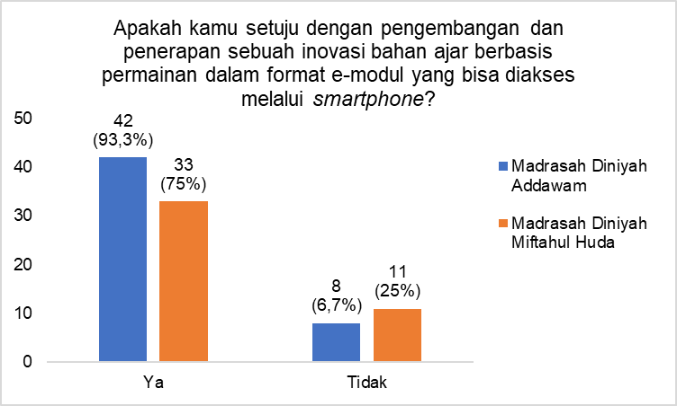

Figure 5. Students' Interest in Innovative Gamification and E-Module Teaching Materials

Based on the data regarding students' willingness to support the development and implementation of gamification-based teaching materials in the form of e-modules accessible via smartphones (Figure 5), the results indicate positive responses from students at both *madrasahs*. At *Madrasah Diniyah Addawam*, 42 students (93.3%) agreed with the implementation of gamification-based e-modules, while 8 students (6.7%) disagreed. Similarly, at *Madrasah Diniyah Miftahul Huda*, 33 students (75%) agreed, whereas 11 students (25%) disagreed. These data illustrate that the majority of students at both *madrasahs* support the use of gamification-based e-modules as a more engaging and interactive tool for *Tajweed* learning. This indicates that the implementation of gamification-based e-modules can be an effective solution to enhance student's understanding and skills in reciting the Quran correctly according to *Tajweed* rules. With an enjoyable approach accessible via smartphones, it is expected that students will be more motivated to continue learning anytime and anywhere, mastering *Tajweed* material more engagingly and effortlessly. The accessibility of gamification-based e-modules allows students to learn independently and flexibly without being constrained by time and place. This can improve their learning consistency, strengthen their understanding of *Tajweed* material, and ultimately help them recite the Quran accurately and properly in accordance with *Tajweed* principles.

Overall, the survey results show that the implementation of gamification-based e- modules accessible via smartphones received positive responses from the majority of students at both *madrasahs*. This reflects a readiness to adopt more interactive and technology-based learning methods, which are expected to encourage students’ enthusiasm and active participation in learning *Tajweed*. Consequently, this will also lead to an improvement in students’ ability to recite the Quran properly and accurately in accordance with established *Tajweed* rules. With strong support from the students, the development and implementation of gamification-based e-modules present a promising step toward enhancing the quality of *Tajweed* learning at *Madrasah Diniyah Addawam* and *Miftahul Huda*.

## DISCUSSION

*Tajweed* learning at *Madrasah Diniyah Addawam* and *Miftahul Huda* highlights challenges in improving students’ ability to recite the Quran in accordance with proper *Tajweed* rules. Based on the survey results, most students still face difficulties in reciting the Quran with accurate *Tajweed*. These difficulties are influenced by various factors encompassing both internal and external aspects. Internal challenges include an unenjoyable learning experience, low learning enthusiasm, and a high level of difficulty in understanding *Tajweed*. External challenges are related to the limited use of varied learning media and the dominance of less interactive traditional teaching methods.

One innovation that can be implemented to address these challenges is the use of gamification-based e-modules. Based on the data obtained, the majority of students at both madrasahs expressed high interest in the application of gamification-based e- modules. At *Madrasah Diniyah Addawam*, 93.3% of students agreed with the implementation of these e-modules, while at *Madrasah Diniyah Miftahul Huda*, 75% of students shared similar interests. This indicates that students are increasingly open to the use of technology in learning, particularly in more interactive and engaging forms such as gamification (Loro et al., 2024). The implementation of gamification can make *Tajweed* learning more appealing and motivate students to study more diligently, as the game elements incorporated into the learning process can enhance student participation and engagement.

However, despite the high enthusiasm of students for gamification-based e- modules, challenges in their implementation must still be addressed. One of these challenges is the readiness of teachers and students to adapt to technology-based learning methods. Technological proficiency is one of the key elements that must be carefully prepared to ensure the learning process runs optimally. Additionally, the development of e-modules that combine educational and game elements must be carried out with caution to maintain a balance between the material being taught and the entertainment aspects offered (Abadi, 2024). Therefore, the development of gamification-based e-modules needs to consider pedagogical aspects to ensure that Tajweed learning remains effective and improves students' Quranic reading quality.

The integration of gamification and e-modules in *Tajweed* learning also creates significant opportunities to develop a more flexible, enjoyable, and interactive learning experience. One of the greatest opportunities lies in enhancing learning accessibility through smartphones, enabling students to access lessons freely without time or location constraints. With this method, students can also learn at a pace that suits their abilities, making the learning process more personalized and adaptive. Furthermore, the implementation of gamification can increase student engagement in the learning process, which in turn can deepen their understanding of *Tajweed* rules comprehensively, ultimately improving their Quranic reading skills. Another opportunity is the introduction of digital literacy, which is becoming increasingly relevant in today’s educational landscape, aligning with global trends that encourage the use of technology in the learning process.

# CONCLUSION

The research results show that the majority of students have access to smartphones and demonstrate a high interest in technology-based learning, particularly through gamification-based e-modules. This system is considered capable of enhancing students' motivation, engagement, and understanding by integrating educational and game elements in a balanced way, thereby improving their ability to recite the Quran properly and accurately according to established *Tajweed* rules. The strong support from students for this innovation reflects their readiness to adopt more modern learning methods that are relevant to the needs of the current era. Thus, the development of gamification-based e-modules can serve as an effective solution to address various challenges in *Tajweed* learning. However, the successful implementation of this method requires careful planning, a balance between educational and entertainment elements, and teacher training to ensure that the use of technology optimally supports learning objectives. This innovation is expected to create a more effective and enjoyable learning process while enhancing the quality of *Tajweed* learning in Quranic recitation at *madrasahs*.

# REFERENCES

Abadi, M. M. R. (2024). Metode Efektif Mengajar Al-Quran dan Tajwid. *Hikmah : Jurnal Studi Pendidikan Agama Islam*, *1*(4). https://doi.org/doi.org/10.61132/hikmah.v1i4.233

Ahmadi, A. (2020). Comparison of Tajwid Learning Outcomes of Batu Ngompal Method With Conventional Method in Taman Pendidikan Al Quran (Tpq) Jejanti Pancor Village, Selong District in 2019. *NUSRA: Jurnal Penelitian Dan Ilmu Pendidikan*, *1*(1), 48–51. https://doi.org/10.55681/nusra.v1i1.7

Anggriani, F. D., Arsih, F., Rahmi, F. O., Padang, U. N., & Biologi, P. (2024). Literature Review : Validitas Pengembangan E-Modul Dalam Pembelajaran Biologi SMA / MA. *Jurnal Ilmu Pendidikan Ahlussunnah*, *7*(2), 130–137.

Ariswan, Firman, & Desyandri. (2024). Pemanfaatan E-Modul Dengan Flip PDF Professional Berbasis Gamifikasi Dalam Meningkatkan Pembelajaran Matematika Di Sekolah Dasar. *Didaktik : Jurnal Ilmiah PGSD FKIP Universitas Mandiri*, *10*(September), 148–158.

Fatihuddin, M., & Abror, A. M. (2020). Edukasi Ilmu Tajwid Dalam Meningkatkan Kemampuan Membaca Al-Quran Santri Pondok Pesantren Hidayatul Mustaqim Bulusari Tarokan Kediri. *Jurnal Pengabdian Kepada Masyarakat Desa*, *1*(3).

Fatimah, K., Viono, T., & Ambarwati, A. (2023). Pengembangan e-modul interaktif berbasis gamifikasi pada pembelajaran teks fabel. *Diglosia: Jurnal Kajian Bahasa, Sastra, Dan Pengajarannya*, *6*(4), 945–958. https://doi.org/10.30872/diglosia.v6i4.728

Hakeu, F., Pakaya, I. I., & Tangkudung, M. (2023). Pemanfaatan Media Pembelajaran Berbasis Gamifikasi Dalam Proses Pembelajaran Di MIS Terpadu Al-Azhfar. *Awwaliyah: Jurnal PGMI Volume*, *6*(2).

Hayati, R., Kartika, Y., & Karim, A. (2025). Pembelajaran Matematika Modern : Teknologi Gamifikasi dan RME dalam Mengasah Kemampuan Pemecahan Masalah. *Journal on Education*, *07*(02), 9507–9516.

Kristiyaningsih, N., & Febrianti, O. H. (2024). Penggunaan e-modul berbasis etnosains untuk meningkatkan keterampilan berpikir kritis siswa smp. *In Proceeding Seminar Nasional IPA*, 356–366.

Latifah, S. N., & Anwar, C. (2022). Al-Qur’an sebagai Sumber Ilmu Pengetahuan. *Gunung Djati Conference Sains*, *8*, 630–638.

Loro, J. P., Sindu, I. G. P., & Wiradika, I. N. I. (2024). Implementasi Game Pendidikan Run Through Time Tentang Aktivitas Manusia Di Zaman Pra-Aksara. *Kumpulan Artikel Mahasiswa Pendidikan Teknik Informatika (KARMAPATI)*, *13*(3), 140–150.

Mamlakhah, & Ibad, A. Z. (2022). Madrasah Diniyah Sebagai Alternatif Pendidikan Agama Islam.

*Bashrah*, *2*(2), 135–149.

https[://www.journal.stitpemalang.ac.id/index.php/bashrah/article/download/501/325](http://www.journal.stitpemalang.ac.id/index.php/bashrah/article/download/501/325) Munawaroh, A., Rusydah, M., Maslia, Sa’adah, T., & Solihuttaufa, E. (2024). Penerapan Hukum

Tajwid Dalam Meningkatkan Kemampuan Membaca Al- Qur ’ an Pada Murid MDTA Nurul Huda Cibutun. *Al-Khidmah: Jurnal Pengabdian Kepada Masyarakat*, *2*(1), 35–40. https://doi.org/10.51729/alkhidmah.21251

Mutmainnah, M., Aunurrahman, A., & Warneri, W. (2021). Efektivitas Penggunaan E-Modul Terhadap Hasil Belajar Kognitif Pada Materi Sistem Pencernaan Manusia Di Madrasah

Tsanawiyah. *Jurnal Basicedu*, *5*(3), 1625–1631. https://doi.org/10.31004/basicedu.v5i3.952 Najati, S. (2023). Pembelajaran Al Qur’an Dengan Aplikasi Tajwid Berbasis Android. *Kalangan:*

*Jurnal Penelitian Dan Pengabdian Kepada Masyarakat*, *1*(1), 30–42.

Nisa, A. H., Mujib, M., & Putra, R. W. Y. (2020). Efektivitas E-Modul dengan Flip Pdf Professional Berbasis Gamifikasi Terhadap Siswa SMP. *Jurnal Pendidikan Matematika Raflesia*, *05*(02), 14–25. https://ejournal.unib.ac.id/index.php/jpmr

Nooviar, M. S., Wahyuni, V. I., & Deviv, S. (2024). Transformasi Pembelajaran: Menghidupkan Keaktifan Belajar Siswa melalui Strategi Gamifikasi di Sekolah Dasar. *Edukatif : Jurnal Ilmu Pendidikan*, *6*(3), 2865–2872. https://doi.org/10.31004/edukatif.v6i4.6992

Pransiska, N., & Maulidya, A. (2024). Fungsi Al-Qur’an bagi Manusia. *Multiple: Journal of Global and Multidisciplinary*, *2*(9), 2926–2940. https://doi.org/10.53563/ai.v1i2.21

Prasetian, S. E. (2023). *Hukum Bacaan Mad Untuk Meningkatkan Minat Belajar Peserta Didik*.

Institut Agama Islam Negeri Palopo.

Rahma, L. V., & Zahroh, A. (2019). Problematika Penerapan Ilmu Tajwid Dalam Membaca Al- Qur’an Pada Peserta Didik Kelas X Sekolah Menengah Kejuruan Negeri 1 Bagor Nganjuk Tahun Pelajaran 2017/2018. *Jurnal Ilmiah Innovative*, *8*, 2355–4053.

Ramadhan, M., Rahmah, H., & Maulana, M. (2024). Efektivitas Metode Pengajaran Ilmu Tajwid Berbasis Multimedia Di Kalangan Mahasiswa. *EduCompassion: Jurnal Integrasi Pendidikan Islam Dan Global*, *01*(02), 89–98.

Srimuliyani. (2023). EDUCARE : Jurnal Pendidikan dan Kesehatan Menggunakan Teknik Gamifikasi untuk Meningkatkan Pembelajaran dan Keterlibatan Siswa di Kelas. *Educare: Jurnal Pendidikan Dan Kesehatan*, *1*(1), 30.

Suparmini, K., Suwindia, I. G., & Winangun, I. M. A. (2024). Gamifikasi untuk Meningkatkan Motivasi Belajar Siswa di Era Digital. *Education and Social Sciences*, *5*(2), 145–148. https://doi.org/doi.org/10.29210/07essr500200

Supriandi. (2021). Analisis Kesulitan Belajar Peserta Didik Membaca Al-Qur’an pada Mata Pelajaran PAI Kelas X SMAN 1 Pinrang. *Al Qodiri : Jurnal Pendidikan, Sosial, Dan Keagamaan*, *19*(1), 56–69.

Supyan, M., Dasuki, M., & Nur, S. (2024). Penerapan Gamifikasi berbasis Web untuk Meningkatkan Motivasi Belajar Sejarah Islam pada Siswa Kelas 4 SDN 2 Jetis Situbondo. *Journal of Pedagogical and Teacher Professional Development*, *1*(1), 47–54.

Zahara, R., Prasetyo, G. E., & Yanti, D. M. (2021). Kajian Literatur : Gamifikasi di Pendidikan Dasar. *SOKO GURU: Jurnal Ilmu Pendidikan*, *1*(1), 76–87. https://doi.org/10.55606/sokoguru.v1i1.1783

Zahro, I. M. F. (2024). Pemanfaatan Gamifikasi Dalam Pembelajaran Pendidikan Islam: Membangun Motivasi Siswa Menghafal Al-Qur’an. *ISTINBATH: Jurnal Kajian Keislaman Dan Informasi Pembinaan Perguruan Tinggi Agama Islam*, *16*(2), 65–77.

Zebua, N., Malik, P. F. P., Al-Hilmiyah, N. A.-A., Zebua, E. N. K., Pebrianti, P. E., Sari, M. S., & Rudiyanto. (2024). Analisis Penggunaan Metode Gamifikasi untuk Meningkatkan Motivasi dan Hasil Belajar Siswa Pada Mata Pelajaran IPA-Biologi. *Jurnal Cakrawala Pendidikan Dan Biologi*, *1*(4), 183–188.